Monitor Service User

Guide

Copyright Agreement

The purchase and use of all Software and Services is subject to the Agreement as defined in Kaseya’s “Click-Accept” EULATOS as updated from time to time by Kaseya at http://www.kaseya.com/legal.aspx. If Customer does not agree with the Agreement, please do not install, use or purchase any Software and Services from Kaseya as continued use of the Software or Services indicates Customer’s acceptance of the Agreement.”

©2021 Kaseya. All rights reserved. | www.kaseya.com

# 

# Monitor Service User

The following solution is intended to compare actual service users with service users provided in the JSON file and send alert if deficiencies are detected.

The solution consists of three parts: the Agent Procedure, the PowerShell script and the JSON file.

The JSON file lists objects that consist of service name ServiceName and array of users ServiceUsers that are granted to run the service.

An example of the JSON file:

[

{

"ServiceName": "OcteumDataBrokerService",

"ServiceUsers": ["OTSA-OLP-SafeTrust", "svc-1mw-safetrust", "OTSA-250ves-SafeTrust", "OTSA-424-SafeTrust", "otsa-5mw-safetrust", "OTSA-onyp-SafeTrust"]

},

{

"ServiceName": "OcteumLnlConnectorCliWrapperService",

"ServiceUsers": ["OTSA-200lib-SafeTrust", "OTSA-225lib-SafeTrust", "OTSA-250ves-SafeTrust", "OTSA-300ves-SafeTrust"]

}

]

# Installation Instructions

1. Modify the **ServicesUsers.json** file to specify required services and eligible users.

**On the VSA Server**

1. Navigate to Agent Procedures → Manage Procedures → Schedule/Create and upload **Monitor Service User.xml** via Import Folder/Procedure.
2. S**et actual email address (addresses) for receiving alert messages:**



**Separate multiple e-mail addresses with commas.**

1. Click on Manage Files



Shared files

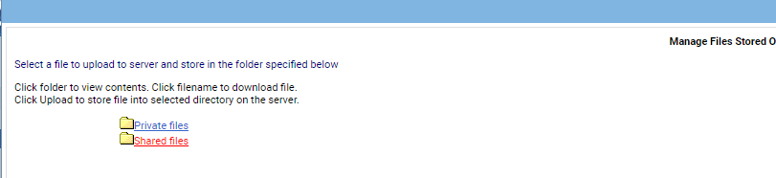

And Upload a file PowerShell script file Test-Service**.ps1**.

1. Upload the modified **ServicesUsers.json** file to the Shared files the same way as the PowerShell script

# Using the Agent Procedure

After the procedure is started it runs the **Test-Service.ps1** PowerShell script.

The script, in turn, for each ServiceName provided in the **ServicesUsers.json** file compares service user account provided in the JSON file with actual service user. If deficiencies are detected the Agent Procedure raises alert and sends e-mail notifications.